

BiKEGG
User Manual

Oveis Jamialahmadi
September 2016

Contents

1 About 2
2 Setup 2
3 Basics 2
3.1 Inferring reaction correspondences 2
3.2 Overlaying the flux distributions on KEGG maps 6
3.2.1 KeggDraw………………...………………………………………………………………………………….8
3.2.2 NetDraw…..………………………………………………………...…………………………………….11
4 Further notes 14
5 Examples 16
5.1 Aerobic versus anaerobic growth conditions 16
5.5.1 Using KeggDraw.……….………...……………………………………………………………………16
5.5.2 Using NetDraw.……….………...…………………………………………...…………………………19
5.2 Dynamic growth conditions 20
6 References 21

1 About
BiKEGG is an open source COBRA toolbox extension, which connects the KEGG and BiGG databases by determining the reaction correspondences between reaction identifiers in the two databases. BiKEGG is capable of overlaying the flux distributions on KEGG PATHWAY maps and finding corresponding reactions for an organism of interest based on the genome annotation presented in KEGG.

2 Setup
Download BiKEGG.zip and unzip the folder in the destination directory. Add the BiKEGG folder to the MATLAB path. To do so, go to Home tab and in Environment section, choose “Set path”; press “Add with subfolders…” button and choose your unpacked BiKEGG folder (Note: these steps are on the basis of MATLAB R2012b and later). Alternatively, in MATLAB, navigate to the BiKEGG folder on your computer, and simply add your folder from command line as follows:
>> addpath(genpath(cd))
>> savepath
Please note that, BiKEGG requires COBRA Toolbox to be installed on the user’s local machine.

3 Basics
BiKEGG toolbox functions fall into two categories: 1) functions responsible for searching and generating a set of corresponding KEGG reaction entries for an input BiGG model; and 2) functions which visualize the flux distributions obtained from COBRA toolbox (or other computational tools) by superimposing the in silico simulations on classical KEEGG pathway images or creating a customized metabolic map extracted from KEGG global metabolic pathway (map01100).

3.1 Inferring reaction correspondences
Function Bigg2Kegg takes a BiGG model as input and searches the KEGG REACTION database to find all equivalent reactions to those in the input model. The input format of the model can be either SBML (.xml) or .mat file. Although most genome-scale metabolic reconstructions in MATLAB format do not contain metKeggID field (KEGG compound IDs), this option has been considered in Bigg2Keggfunction for metabolic reconstructions such as RECON 2¹ for which this field and pertinent data are provided. Nevertheless, KEGG compound IDs for model reconstructions in SBML format are not generated when readCbModel function of COBRA toolbox² is called. Hence, KEGG metabolite identifiers are collected from metabolite and reaction namespaces in BiGG knowledgebase (http://bigg.ucsd.edu/data_access). However, this set of KEGG compounds does not completely cover those provided in COBRA models. Therefore, KEGG compounds are algorithmically extracted from the annotation fields within the input model. Each metabolite in BiGG models may contain more than one KEGG compound equivalences, as opposed to the human metabolic reaction (HMR)³ and RECON 2 for which each metabolite corresponds to one KEGG compound ID. Therefore, in the first step, all equivalent KEGG compounds for each BiGG metabolite are extracted, except for water and hydrogen peroxide, which respectively KEGG IDs of C00001 and C00027 were considered and other annotation data in the associated BiGG model were neglected. Inspecting the RECON 1 model showed that some metabolites have absent or wrong KEGG compound annotations. For instance, the KEGG compound ID provided for the BiGG metabolite 3aib__D is C03265, which is not a valid entry in KEGG database. The correct KEGG ID for this compound is C01205 representing the compound (R)-3-Amino-2-methylpropanoate. An example for an absent KEGG compound annotation in RECON 1 is the metabolite 2amac, which the correct KEGG compound ID for this metabolite is C02218 representing the compound Dehydroalanine. An updated version of this reconstruction is provided in the toolbox folder. All these modifications are incorporated in the algorithm in order to supplement the list of KEGG compounds extracted from each BiGG model with the manually found KEGG compounds. Owing to the fact that there might be more than one KEGG compound ID for each BiGG metabolite, all combinations (permutations) of KEGG IDs are considered for inferring reaction correspondences. Based on the number of KEGG compound equivalences for each BiGG metabolite, the size of this permutation matrix can change. The algorithm then searches the KEGG database to find a unique KEGG reaction (if any) in which all metabolites in the associated BiGG reaction are present and the number of metabolites in the BiGG reaction is identical to those in the potential KEGG reaction. This restricted condition perfectly identified reaction correspondences between two databases. Nevertheless, a “soft condition” was also defined to identify those KEGG reactions for which the number of metabolites in the two databases can only differ by one metabolite from the pertinent BiGG reaction (e.g. if the number of metabolites in a certain BiGG reaction is n, then the number of metabolites in the possible corresponding KEGG reaction can either be n+1 or n-1). The set of reactions identified by this approach were manually verified to ensure the accuracy of the reaction correspondences. This set of pruned reactions were stored as a plain text (included in the toolbox folder), and due to the fact that BiGG reaction identifiers are universal, each new BiGG model will be checked with this set of pruned reactions to include/exclude extra KEGG reactions which cannot be found with the restricted condition described above. For instance, KEGG reaction ID R01466 was found to be the equivalent of the BiGG reaction PTHRpp. Interestingly, some of the reactions found by this approach were not included in MetRxn⁴ database (e.g. reaction identifiers of IDOND and 3HCINNMH). Since some KEGG reactions are elementally or charge (hydrogen imbalance) unbalanced, two additional conditions were added to the algorithm in order not to overlook those reactions in KEGG which are not hydrogen balanced; first, if hydrogen was part of a reaction in the input BiGG model, an additional row consisting of all reaction components without hydrogen was constructed and added to the permutation matrix. For instance, the BiGG reaction 34DHPHAMT corresponds to the KEGG reaction R03304, whereas the former has an extra hydrogen metabolite as one of its reaction components. In contrast to the first condition, hydrogen in the second condition was added as an extra metabolite to the reaction components in the permutation matrix. In this case, a KEGG reaction such as R08549 corresponding to BiGG reaction AKGDm has an extra hydrogen compound as one of its reaction components. As an additional layer of research, the algorithm also searches for multi-step reactions in the set of found KEGG reactions and decomposes these reactions in a series of single-step reactions. This is especially useful for the visualization purpose. For instance, the KEGG reaction ID R08549 corresponds to the BiGG reaction AKGDH, which is a member of the TCA cycle (citrate cycle). However, this KEGG reaction is not a part of the TCA cycle of the KEGG PATHWAY database and, in fact, R08549 is a multi-step reaction comprising of four single-step reactions participating in the TCA cycle (R00621+R03316+R02570+R07618).
To generate equivalent KEGG reactions for a new BiGG model, in the command window type:

>> Bigg2Kegg(‘bigg’)

A dialog box will be opened to retrieve the model file. User may want to choose the model either in .xml or .mat file, which in the latter case, the model has to have the metKeggID field. Bigg2Kegg can also take HMR database in Excel spreadsheet format, which in this case, the input format is Bigg2Kegg(‘hmr’).Bigg2Kegg allows the user to manually verify the potential corresponding reactions identified by “soft condition” via a simple GUI as shown in Fig. 1.

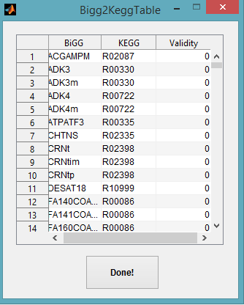
Fig. 1. Manual verification of reactions identified by “soft condition”

As displayed in Fig. 1, the validity of each pair of corresponding reactions is determined by a number, with zero denoting inequivalent reaction pairs (default). If two reactions are equivalent, the validity digit should be changed to any number except zero (preferably 1). This set of manually verified reaction pairs will then be appended to the already existing PrunedRxns.txt file, which contains all manually verified reaction correspondences. Finally, the output data structure including corresponding reactions between two databases will be saved to the BiGG2KEGG folder in the main toolbox folder.
Overall, 79 BiGG models were examined with this approach and their corresponding KEGG reactions were generated. Furthermore, all shared reactions among all these models were identified and stored as a separate .mat file (namely UniModel).
UniModel can be further used to generate a list of all corresponding reactions for an organism of interest, which may be particularly beneficial for initial pre-draft reconstruction process. Precons (Pre-reconstruction), is a simple GUI developed for this purpose. Precons can be easily accessed by typing
>>Precons
As depicted in Fig. 2, Precons is arranged in two sections: 1) Organism selection, in which the target organism is selected by a three-letter code, and 2) Biograph, which visualizes the interactions among genes, KEGG reaction and BiGG reaction identifiers using biograph object in MATLAB. If the checkbox “Activate biograph” is marked, the list of pathways associated with the target organism will be displayed in the “pathway selection” listbox, and user may select biograph type and pathway name for which the set of interconnected data to be visualized.
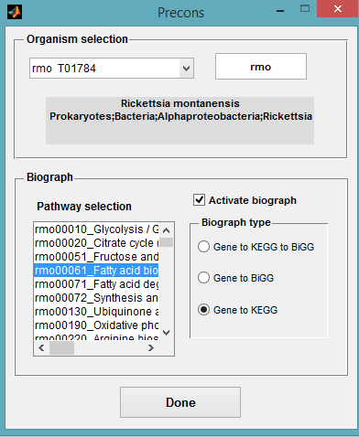
Fig. 2. Snapshot of Precons GUI

A sample biograph for the query organism eco (Escherichia coli K-12 MG1655) in pentose phosphate pathway and type of “gene to KEGG to BiGG” is also shown in Fig. 3.

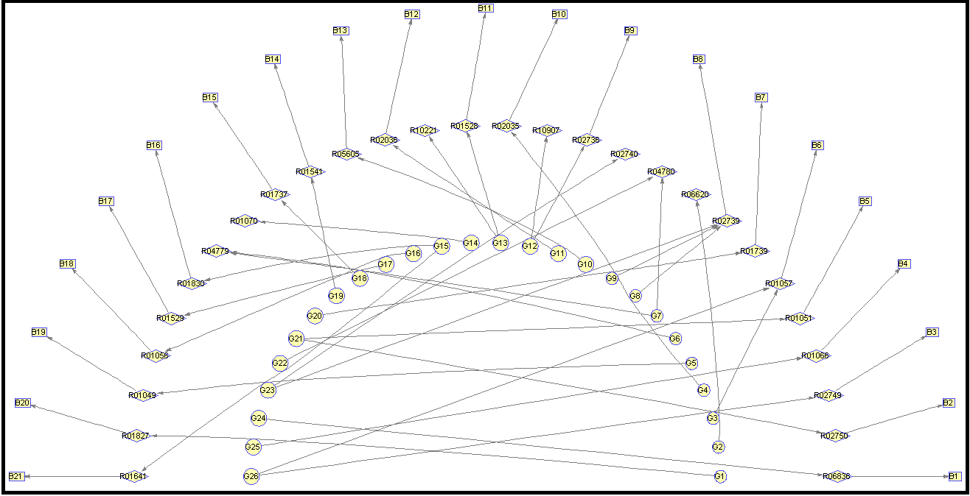
Fig. 3. A sample output biograph for Escherichia coli K-12 MG1655

3.2 Visualizing the flux distributions
Three main functions (GetKegg, KeggDraw and NetDraw) play the major role in the visualization process. GetKegg reads input flux distributions (either from experimental samples or from computational results of COBRA toolbox) and the set of BiGG reaction IDs (Bigg) corresponding to the flux data (Inflx). The syntax for the function is as follows:
>>[MapChoice,Outflx,RxnCds] = GetKegg(Bigg,Inflx,ModelName)
On the basis of previously generated KEGG reaction correspondences for the input BiGG model (ModelName), the function retrieves the set of equivalent KEGG reactions to those in the input model, and notifies the user when some BiGG reaction correspondences cannot be found. The function then allows the user to manually fill the missed reactions as shown in Fig. 4.
Nevertheless, if the user fail to fill the entire list of missed reactions, unknown BiGG reaction IDs will be trimmed off. Furthermore, the user can choose the set of KEGG pathways to be visualized in the next step via a simple GUI as depicted in Fig. 5. Pathway names are sorted based on the descending order of reaction equivalence number (e.g. the first pathway in the list box has the highest number of reaction correspondences), and user may select one or more pathways for visualization purpose. Finally, a set of equivalent KEGG reactions for the input BiGG model (RxnCds), the set flux data corresponding to this set of reactions (Outflx), and a number of user selected KEGG maps (MapChoice) are generated for the next step.
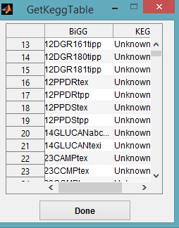
Fig. 4. Missed (unknown) reaction correspondences for the input model

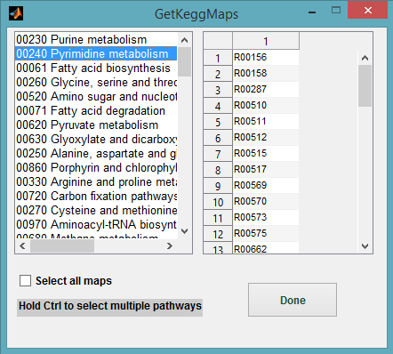
Fig. 5. Selection of target pathway(s) for visualization

BiKEGG has two main functions for visualizing the flux rates: 1) KeggDraw, which employs classical KEGG pathway images for data visualization, and 2) NetDraw, which is originally based on the global pathway map of KEGG and can extract a subset of this map containing all KEGG pathways for which there exists at least one flux carrying reaction or generate a customized metabolic map only for selected pathways of interest.

3.2.1 KeggDraw
KeggDraw is capable of visualizing the input flux distributions in both static and dynamic conditions. Therefore, the input flux data is an m×n matrix (which m corresponds to the KEGG reaction IDs, and n corresponds to flux distributions at various time points). Obviously, n is 1 in the case of static conditions. Moreover, the input flux data may contain results obtained under two different conditions to be compared. To display the associated input data on the KEGG pathway of interest, the algorithm first reads the corresponding KGML file from KEGG API, and extracts the KEGG reaction identifiers and coordinates of nodes (rounded rectangular boxes or lines in some cases). Considering that KGML files are primarily created for graphical representations of KEGG pathways⁵, the extracted information can be exploited to integrate the input data with KEGG pathway images. To this end, the input KEGG reaction IDs are compared to those present in the selected pathway, and matched reactions are selected. This set of matched reactions will be further analyzed to find the so-called “consistent reactions” for the KEGG pathway of interest. Consistent reactions form the list of all present reactions in a given KEGG pathway, which are not included in the input KEGG reactions, but are identical to some input KEGG reactions as the result of different metabolite representations (mainly due to different stereo and chiral information, such as alpha, beta, L-, D-, etc.). For instance, the KEGG reaction R00299 (ATP + D-Glucose <=> ADP + D-Glucose 6-phosphate) corresponds to the BiGG reaction HEX1; however, this reaction does not participate in the pathway Glycolysis/Gluconeogenesis. Whereas, the KEGG reactions R01600 (ATP + beta-D-Glucose<=> ADP + beta-D-Glucose 6-phosphate) and R01786 (ATP + alpha-D-Glucose<=> ADP + alpha-D-Glucose 6-phosphate) are both identical to R00299, and participate in the mentioned pathway. In order to find the list of consistent reactions for a given KEGG pathway, the algorithm searches for KEGG reactions which do not belong to the target KEGG pathway, and based on the reaction-enzyme relations, the set of reactions catalyzed by the same enzymes associated with that particular reaction will be further investigated. Potential consistent reactions are those for which the weight of their reaction components are completely matched with that of the reaction under investigation. The algorithm also allows the user to select the flux data of reactions for which there is more than one equivalent BiGG reaction (i.e. identical KEGG IDs for multiple BiGG reactions). This is partly rooted in the fact that KEGG database does not provide any information about compartmentalization. For example, BiGG reactions ACS2 and ACCOALm are both equivalent to KEGG reaction R00926. In such cases, user can decide which flux data to use for the visualization purpose (Fig. 6). However, user may simply disregard this GUI by pressing the “Done” button, and let the algorithm choose the first BiGG reaction among the set of BiGG IDs (e.g. PAPA120 for R02239 in Fig. 6).

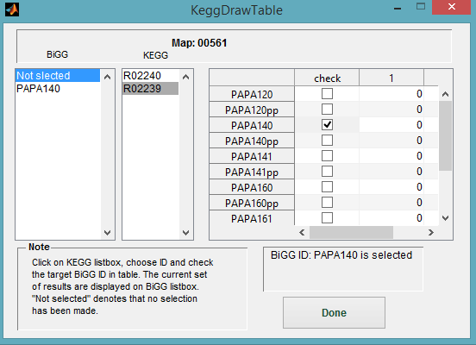
Fig. 6. BiGG reaction selection among identical KEGG identifiers

The algorithm then maps flux values on pertinent enzyme boxes of each map using a jet colormap (i.e. red colours denote high flux rate and blue colours denote low flux rates), which maps flux values to a broad colour spectrum in the pathway of interest. The colormapping for input data is calculated according to the respective minimum and maximum flux values. To this end, flux values are normalized according to the length of the corresponding enzyme boxes, so that the maximum flux value among all reaction identifiers in a set of perturbations fills the entire box. When the input data comprises of flux rates of two different models, the original box is split into two identical boxes. The function syntax is as follows:
>>KeggDraw(Outflx,RxnCds,MapChoice,flxType,InOpts)
Where flxType determines the nature of input data (Outflx): 1 for entirely filling the enzyme boxes, and 2 for dividing the boxes into two identical parts. In the latter case, first and second set of data (e.g. associated with aerobic/anaerobic conditions) respectively fill the upper and lower part of each enzyme box. Furthermore, additional options (Inopts) are provided in KeggDraw to contribute to a better interpretation of the visualized data. These options are briefly discussed as follows:
- The user is offered to extract and save visualized flux patterns in a variety of image formats and resolutions for subsequent analysis (Fig. 7). Additionally, a video or animated GIF image can be generated from the sequence of saved images (for time-series data). In this case, the user is asked to select the folder in which a set of time-series images is placed. The user may also enter the desired frame rate in the opened dialog box. The generated video will be saved in the same directory as the image folder.

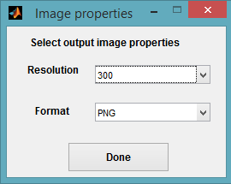
Fig. 7. Save the visualized flux patterns

- Time points associated with time-series values can be entered as a row vector. Otherwise a sequence of natural numbers is displayed on visualized maps.
- The user can choose the time unit corresponding to “time points” to be displayed on visualized maps (the default string is ‘No unit’).
- The user can enter an arbitrary threshold below which the flux values are not depicted on the enzyme boxes, and instead “0” will be printed on pertinent boxes (default is 0.001).
- A time value, which indicates the time-step between two consecutive images in an animated manner (i.e. lower values result in slower animated sequence of images and vice versa) can determined by the user.
- Visual properties, such as font characteristics (font name, font size, etc.), text color and enzyme box color can also be adjusted by the user through a simple GUI (Fig. 8).

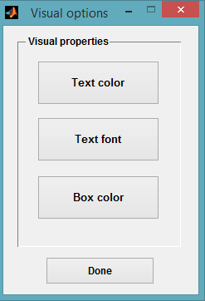
Fig. 8. Adjusting visual properties of overlaid data

- The user may also decide to operate the KeggDraw in offline or online mode. In case of offline mode, KEGG maps and related KGML files in KEGGmaps folder of BiKEGG will be utilized (default mode: online).

3.2.1 NetDraw
NetDraw uses manually created KEGG global map (map01100) to visualize the metabolic fluxes from in silico simulations in an integrated manner⁶⁻⁷. Nodes and lines (edges) in the map represent metabolic compounds and enzymatic reactions respectively. The overall structure of NetDraw is similar to that of the KeggDraw, except that several customization options as post-processing steps are provided. The function syntax is also quite similar to KeggDraw, however, flxType is not applicable in this case:

>>NetDraw(Outflx,RxnCds,MapChoice,InOpts)
Here also the KGML file of global metabolic map was exploited to explore and analyze the associated detailed information. The accompanying KGML file of global map contains the reaction coordinates, however, these discrete position coordinates cannot be directly used to reproduce the reaction edges due to the low number of data points. Therefore the original data points were interpolated to generate spatially continuous points for each reaction⁸. The fully documented function pixFit is developed to perform such interpolation when KEGG global map is updated. Furthermore, NetDraw determines the reaction directionalities by adding arrowheads to reaction edges. However, when possible, the directionality of enzymatic reactions are determined based on BiGG models which is of practical interest when dealing with COBRA models. Two-headed arrows are used for reversible reactions, with the filled arrowheads representing the direction of reaction in the simulated flux distribution and white-filled arrowheads indicate otherwise. The arrowhead width and length can be easily adjusted, however, these parameters change continuously in the current settings of NetDraw based upon the reaction line width. One interesting feature of NetDraw is its capability to superimpose the flux rates on complete global metabolic pathway map (map00100), create a customized metabolic map for certain metabolic pathways of interest or all KEGG pathways for which there exists at least one flux carrying reaction. One problem with this customization approach is that there are numerous biochemical reactions in global metabolic map which span more than one pathway (duplicates) and cannot be identified solely from the information in the pertinent KGML file. To overcome this hurdle, a reaction-reaction graph is generated from unsigned stoichiometric coefficients, with nodes representing reactions and edges representing the interaction between them. The nodes in this graph are connected if they share at least one chemical compound. A MATLAB biograph object is then created and disconnected subgraphs are identified using MATLAB Bioinformatics Toolbox function “conncomp”. To identify duplicate reactions not belonging to the selected metabolic pathways, each duplicate reaction is removed if: 1) it participates in disconnected subgraph and 2) it does not share a color code with color codes in the maximal connected part of the biograph.
Nevertheless, multi-step reactions and their associated single-step reactions usually do not contain substrate/product information, and thus cannot be detected through reaction-reaction graph approach. This problem is addressed by finding the compounds participating in these reactions from KEGG API and then checking if they share any compound with those in the maximal connected part of the created biograph. As the result, only reactions in the selected pathways of interest will be included in the final customized metabolic map.
Additionally, there also exist “overlapping reactions” which share the same position in the global metabolic map, and may cause ambiguity when there exist multiple reactions with different flux rates to be overlaid on the same position in the metabolic map. To avoid such ambiguity, “overlapping reactions” can be overlaid adjacent to each other; however, hovering the mouse cursor over any part of the created map will reveal a tooltip with information about all reactions belonging to the same position as well as their flux rates, KEGG reaction identifiers and corresponding BiGG identifiers (Fig. 9).
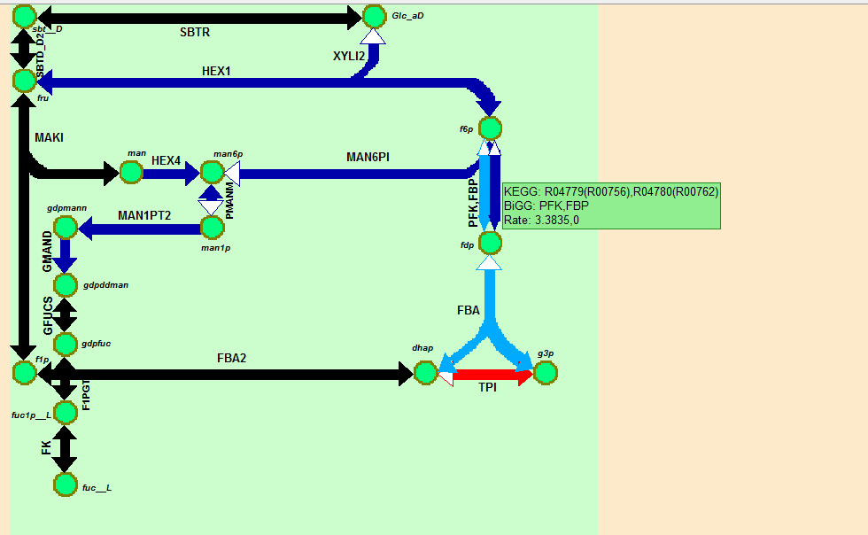

Fig. 9. A customized map for Fructose and mannose metabolism (map00051). Reaction abbreviations PFK and FBP share two compounds (f6p and fdp), and therefore are overlapping. Hovering the cursor over this area reveals a tooltip (green box) containing all associated information. The reaction identifiers inside the parentheses represent consistent reactions.

The color mapping is similar to that of the KeggDraw except that enzymatic boxes are replaced with lines in this case. NetDraw offers several post-processing features which can be accessed through a GUI tool (MapAdjuster) after creating the map based on the default options (Fig. 10). These features include line width, color (background, inactive reactions (those not present in the current COBRA model) and compounds) and textual information (flux rates, custom map title, KEGG and BiGG compound/reaction identifiers). Also, overlapped reactions and colormap can be removed when needed.
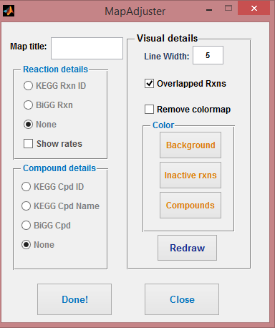
Fig. 10. Snapshot of the MapAdjuster GUI for post-processing of maps created by NetDraw

4 Further Notes
All parts of the toolbox, except for Precons section, are capable of operating in both offline and online modes. Hence, all relevant parts of KEGG database are first downloaded to the local directory to be used in related functions. Furthermore, all these parts can be updated through a simple GUI (Fig. 11) via the following command:
>>UpdateDBase

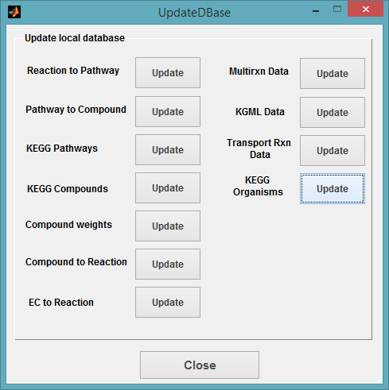

Fig. 11. Snapshot of the UpdateDBase GUI for updating the local database
The GUI consists of several parts, which can be updated independently. Each part downloads distinct local data belonging to different functions of BiKEGG, and is discussed as below.
- Reaction to Pathway retrieves reaction-pathway associations.
- Pathway to Compound retrieves pathway-compound associations.
- KEGG Pathways retrieves list of KEGG pathways.
- KEGG Compounds retrieves list of KEGG compounds.
- Compound Weights retrieves weight of KEGG compounds.
- Compound to Reaction retrieves compound-reaction associations.
- EC to Reaction retrieves EC number-reaction associations.
- Multirxn Data retrieves information of KEGG reaction entries and stores them in OfflineRxnData folder for use in identifying multi-step reactions.
- KGML Data retrieves KGML and image data of KEGG pathways and stores them in KEGGmaps folder for use in KeggDraw function in offline mode.
- Transport Rxn Data generates all KEGG reactions in which there are 2 or 4 KEGG compounds from data of “Compound to Reaction” and “Compound Weights” for identifying potential equivalent transport reactions.
- KEGG Organisms retrieves list of KEGG organisms.

5 Examples
Here, two different applications of BiKEGG for visualizing the flux data are represented, one for comparing two different growth conditions, and another for the dynamic growth conditions. Both examples can be found in the Examples folder of BiKEGG.
  - Aerobic versus anaerobic growth conditions
5.1.1 Using KeggDraw
In this case, the experimental data and measured fluxes of Chen et al.⁹ were taken to analyze the aerobic and anaerobic growths of wild-type E. coli (K-12MG1655) using flux balance analysis (FBA)¹⁰, as described in the following instructions:
Organize GetKegg inputs by executing AeroAnaero.m.
>>AeroAnaero
>>[MapChoice,Outflx,RxnCds] = GetKegg(Bigg,Inflx,ModelName);
GetKeggTable (as in Fig. 4) will appear, which can be neglected by pressing the “Done” button. GetKeggMaps will then ask for pathway selection (as in Fig. 5). Scroll down the pop-up menu, select the Pentose phosphate pathway, Glycolysis / Gluconeogenesis and Citrate cycle (TCA cycle) and press “Done” button (hold Ctrl while selecting). To call KeggDraw function, some optional inputs can be provided as follows:
Type the following commands to export the visualized images and execute in the offline mode, respectively.
>>Opts.sval = 1;
>>Opts.netstat = 0;
Now, the KeggDraw function can be executed.
>>KeggDraw(Outflx,RxnCds,MapChoice,2,Opts)
The flxType is set to 2, to split the enzyme boxes into two identical parts for a convenient comparison. After processing the “consistent reactions”, a dialog box will then beckon the user to select the target directory to save the output images.
As discussed in the main text, ¹³C net fluxes of central metabolism indicate that the aerobic and anaerobic fluxes are characterized by high carbon flows through glycolysis. Furthermore, there was no significant flux through α-ketoglutarate dehydrogenase and succinyl-CoA synthetase in TCA cycle for aerobic condition, and also, this pathway operates poorly in anaerobic condition. The activity of oxidative pentose phosphate pathway for aerobic and anaerobic conditions was high and moderate, respectively. The FBA results shown in Fig. 12, 13 and 14 clearly corroborate the previous findings.

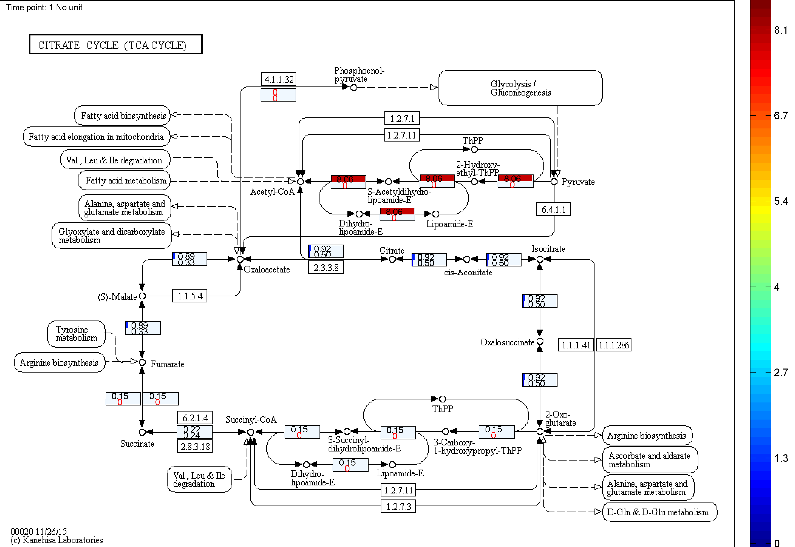
Fig. 12. A comparison between aerobic and anaerobic growth conditions in TCA cycle. Upper section: aerobic; lower section: anaerobic.

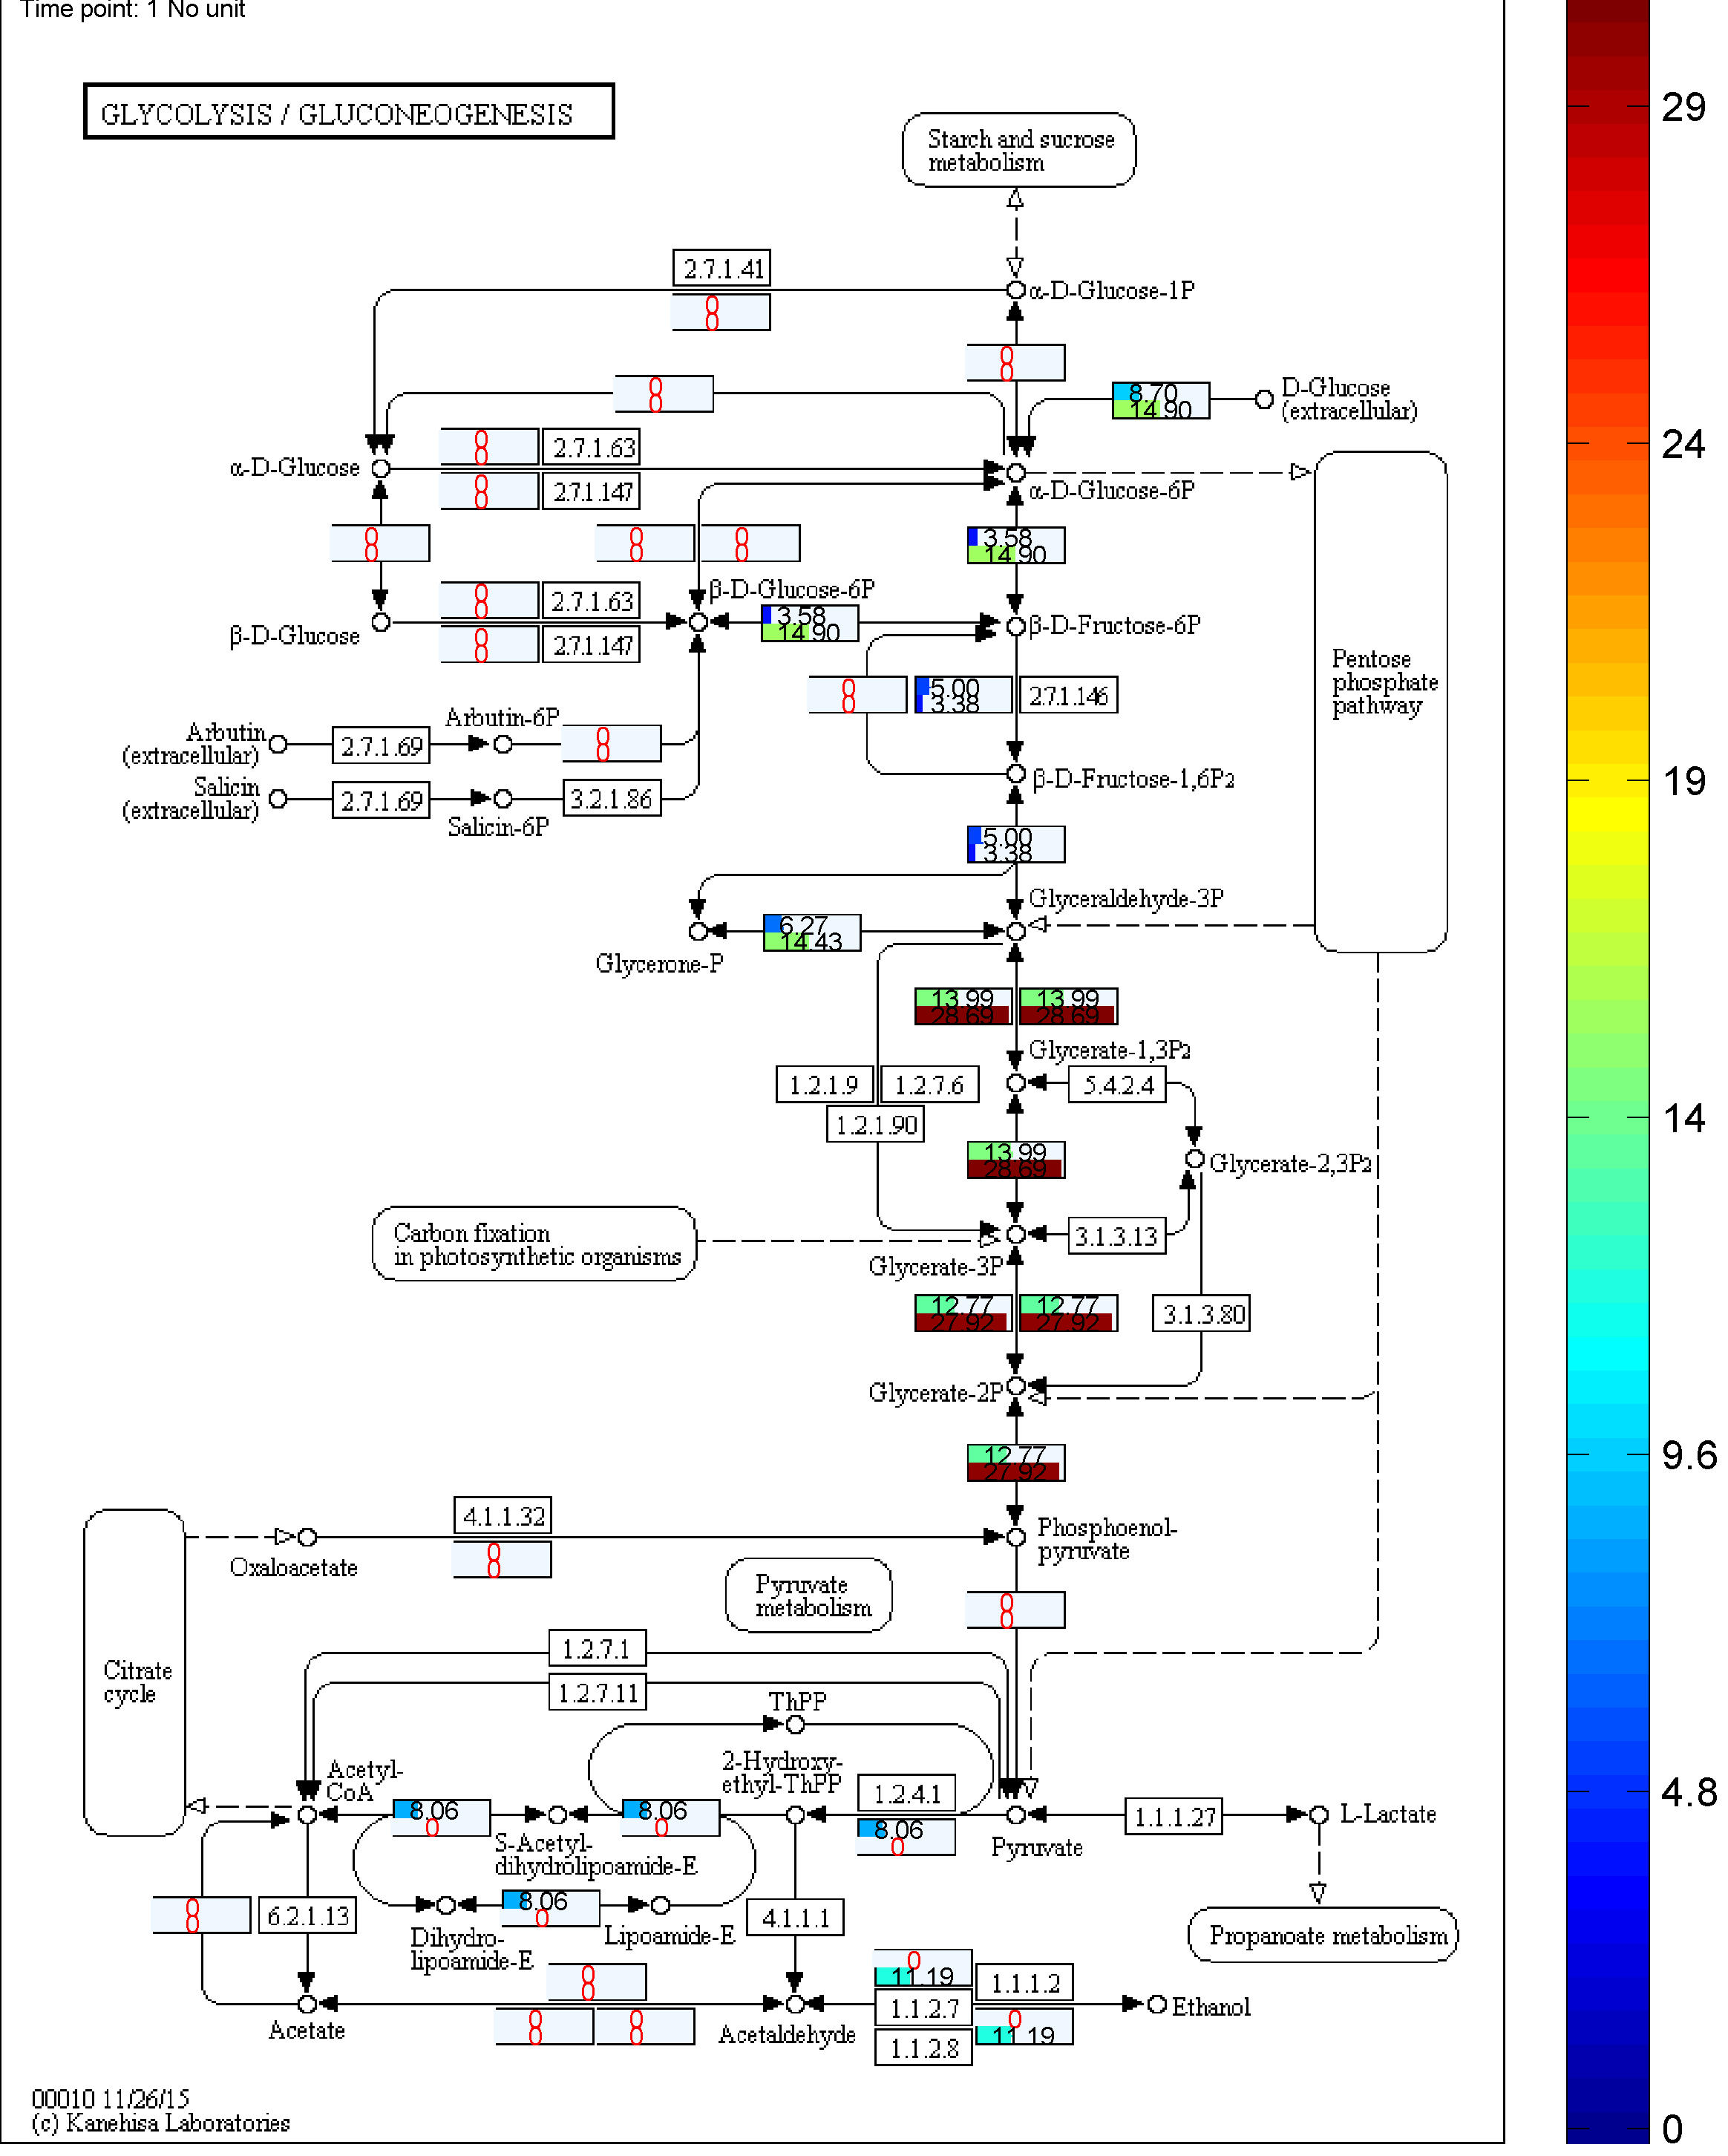
Fig. 13. A comparison between aerobic and anaerobic growth conditions in Glycolysis pathway. Upper section: aerobic; lower section: anaerobic.

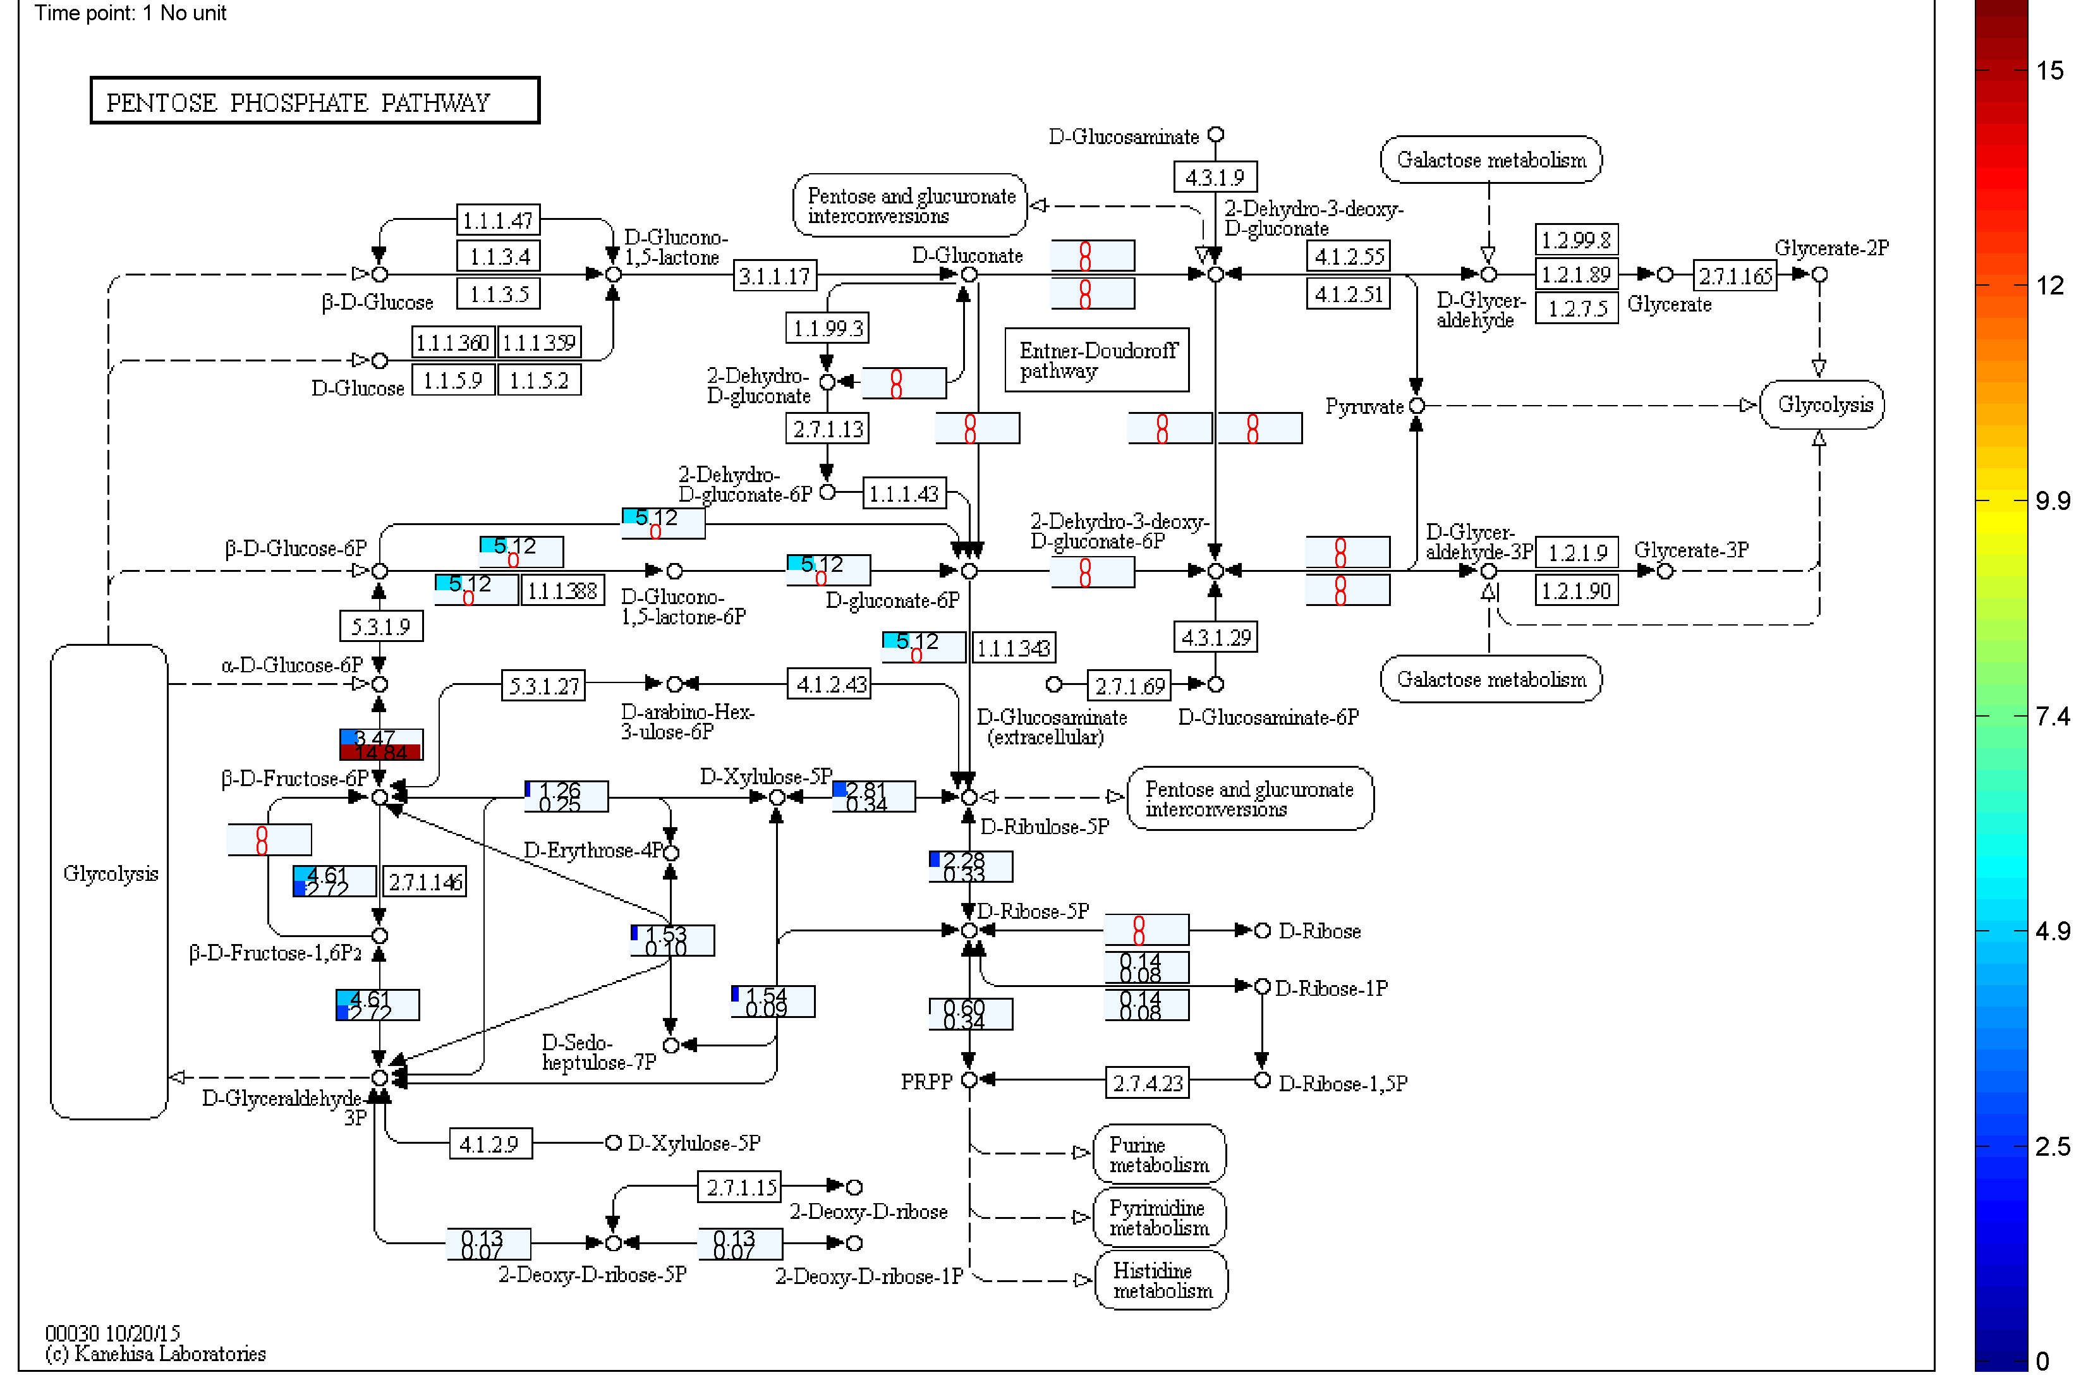
Fig. 14. A comparison between aerobic and anaerobic growth conditions in pentose phosphate pathway. Upper section: aerobic; lower section: anaerobic.

    - Using NetDraw
To generate a customized metabolic map reported in the main text, the above-mentioned procedure for KeggDraw is employed. Nonetheless, user may wish to superimpose the numerical results on all KEGG pathways for which there exists at least one flux carrying reaction. In such a case, user should check “select all pathways” checkbox in the GetKeggMaps (Fig. 5). Now, type the following commands to export the visualized customized metabolic maps and execute in the offline mode, respectively.
>>Opts.sval = 1;
>>Opts.netstat = 0;
Now, the NetDraw function can be executed.
>>NetDraw(Outflx,RxnCds,MapChoice,Opts)

The output image is shown in Fig. 15.

Fig. 15. The customized metabolic map for FBA results from the study of Chen et al.⁶. All KEGG pathways with at least one flux carrying reaction are shown in this map. For presentation purpose detailed information is not provided.

  - Dynamic growth conditions
To track the dynamics of microbial growth, glucose uptake rate and growth measurement data at various time points were collected from the work of Narang et al.¹¹ In the first, run the Dynamicgorwth.m. Columns in Inflx associates with various time intervals. The instructions for GetKegg are the same as before.
>>Dynamicgorwth
>>[MapChoice,Outflx,RxnCds] = GetKegg(Bigg,Inflx,ModelName);
In addition to the previous options for KeggDraw, time points and time unit corresponding to the experimental results can be provided. Moreover, an animated GIF file can be generated from the sequence of exported images.
>>Opts.mtime = [1,1.5,2,2.5,3,3.5,4,4.5,5];
>>Opts.timeunit = ‘hr’;
>>Opts.svid = 2;
>>KeggDraw(Outflx,RxnCds,MapChoice,1,Opts)

Both exported images and animated GIF file can be found in Examples folder.

References
- I. Thiele, N. Swainston, R. M. Fleming, A. Hoppe, S. Sahoo, M. K. Aurich, H. Haraldsdottir, M. L. Mo, O. Rolfsson, M. D. Stobbe, S. G. Thorleifsson, R. Agren, C. Bölling, S. Bordel, A. K. Chavali, P. Dobson, W. B. Dunn, L. Endler, D. Hala, M. Hucka, D. Hull, D. Jameson, N. Jamshidi, J. J. Jonsson, N. Juty, S. Keating, I. Nookaew, N. Le Novère, N. Malys, A. Mazein, J. A. Papin, N. D. Price, E. Selkov, M. I. Sigurdsson, E. Simeonidis, N. Sonnenschein, K. Smallbone, A. Sorokin, J. H. van Beek, D. Weichart, I. Goryanin, J. Nielsen, H. V. Westerhoff, D. B. Kell, P. Mendes, B. Ø. Palsson, Nat. Biotechnol., 2013, 31, 419-425.
- J. Schellenberger, R. Que, R. M. Fleming, I. Thiele, J. D. Orth, A. M. Feist, D. C. Zielinski, A. Bordbar, N. E. Lewis, S. Rahmanian, J. Kang, D. R. Hyduke and B. Ø. Palsson, Nat. Protoc., 2011, 6, 1290-1307.
- R. Agren, S. Bordel, A. Mardinoglu, N. Pornputtapong, I. Nookaew, J. Nielsen, PLoS Comput. Biol., 2012, 8, e1002518.
- A. Kumar, P. F. Suthers and C. D. Maranas, BMC Bioinformatics, 2012, 13, 6.
- C. Wrzodek, F. Büchel, M. Ruff, A. Dräger and A. Zell, BMC Syst. Biol., 2013, 7, 15.
- M. Kanehisa, S. Goto, Y. Sato, M. Furumichi and M. Tanabe, Nucleic Acids Res., 2012, 40, 109-114.
- S. Okuda, T. Yamada, M. Hamajima, M. Itoh, T. Katayama, P. Bork, S. Goto and M. Kanehisa, Nucleic Acids Res., 2008, 36, 423-426.
- J. D’Errico, Distance based interpolation along a general curve in space using interparc (https://www.mathworks.com/matlabcentral/fileexchange/34874-interparc), MATLAB Central File Exchange, 2012, Retrieved June 15, 2016.
- X. Chen, A. P. Alonso, D. K. Allen, J. L. Reed and Y. Shachar-Hill, Metab. Eng., 2011, 13, 38-48.
- J. D. Orth, I. Thiele and B. Ø. Palsson, Nat. Biotechnol., 2010, 28, 245-248.
- Narang, A.; Konopka, A.; Ramkrishna, D. New patterns of mixed-substrate utilization during batch growth of Escherichia coli K12. Biotechnol. Bioeng. 1997, 5, 747-757.

